The University of Southern Mississippi has received the underwater sensor system shown below. It is currently undergoing acceptance testing and configuration. The system uses

18-temperature depth sensors, 2-DO sensors, 1-ADCP, 1-hydrophone, 1-tidal wave sensor, a surface buoy mounted weather station and wave sensor.

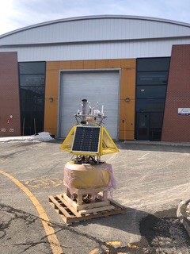

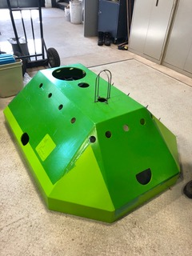

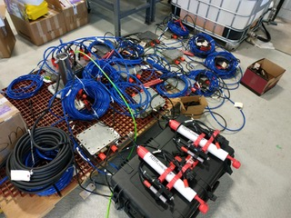

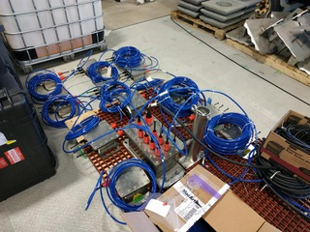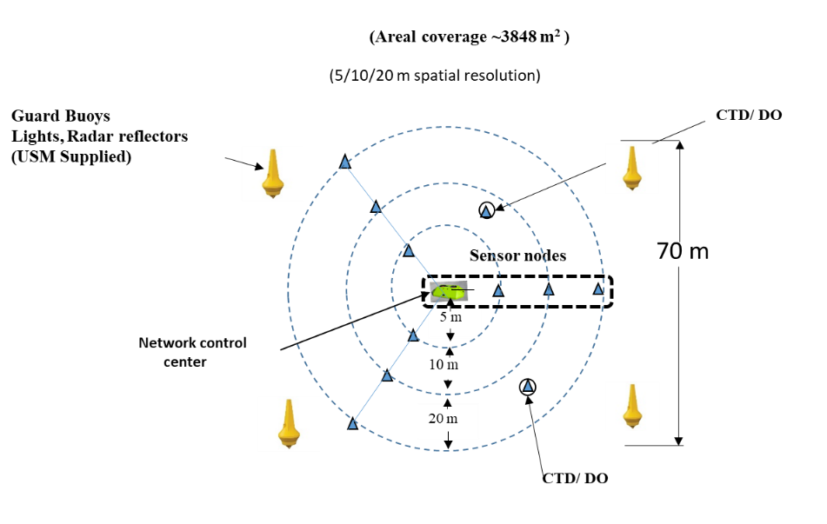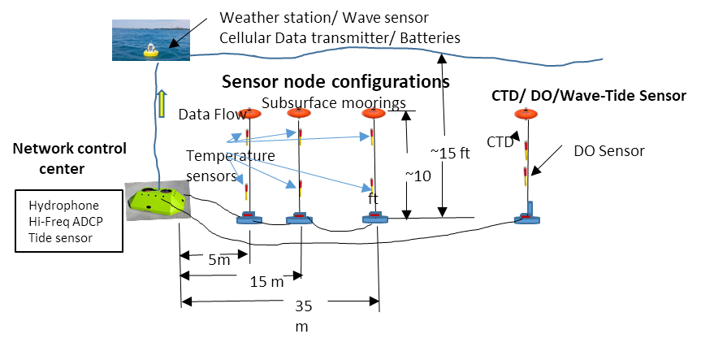

Temperature data examples taken during the testing and configuration tests.

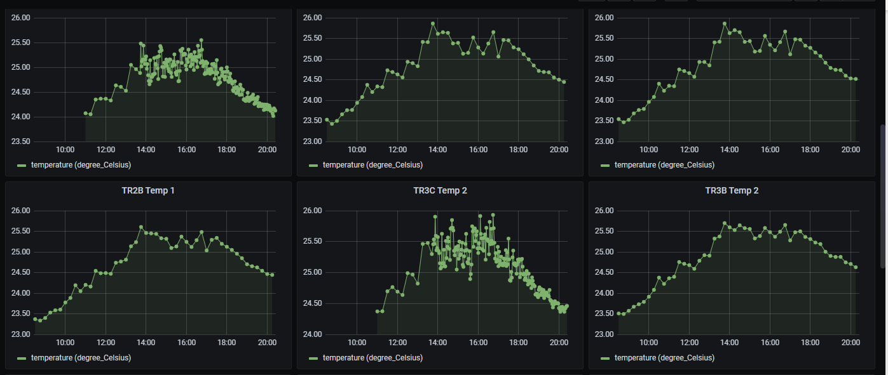

15 min sample rate

2 min sample rate